FIRST CONSOLIDATED BANK

GUIDE FOR THE INSTALLATION OF NETLINKS ONLINE DTR.

- Open Firefox or Chrome browser.
- Log on to https://www.fcb.com.ph/onlinkz.
- If Security Alert pops out, click Yes. Or, please see steps 28 and 29 for alternative instruction.
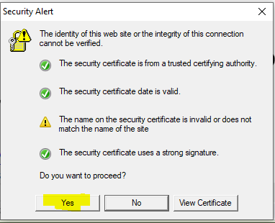

- Click windows_dtr_access.exe to download the installer.
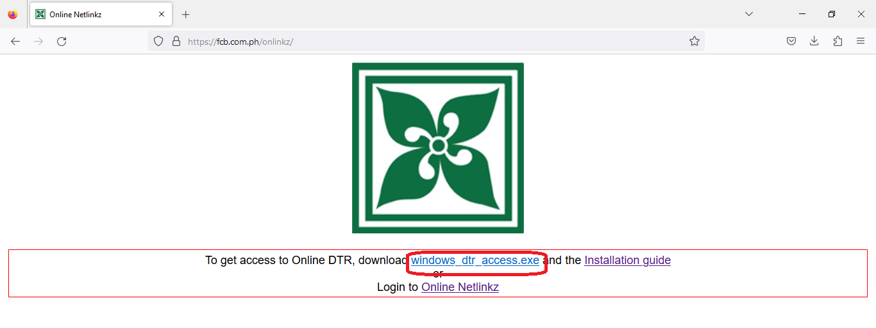

- For Chrome browser users, follow steps 6-10. For Mozilla Firefox users, proceed to step 11
- In case Suspicious download blocked pops out, click it.
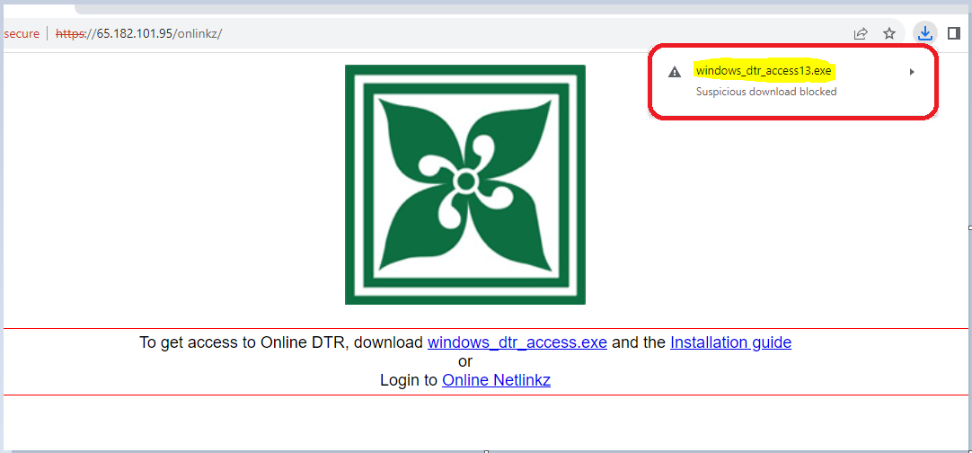

- Then, click Download suspicious file.
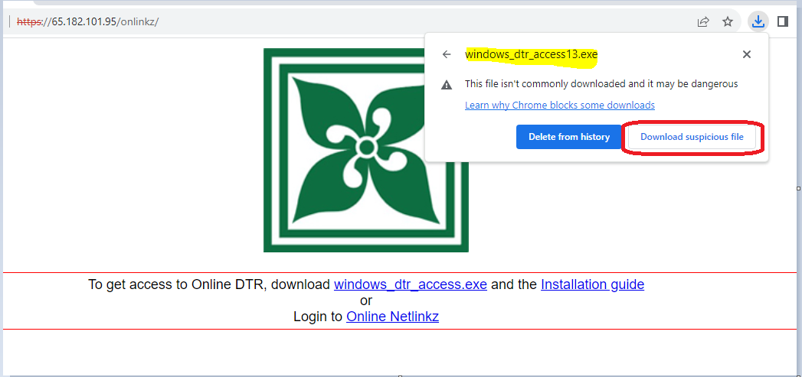

- If a new window would appear, click SAVE FILE to download the exe (windows_dtr_access13.exe) file.
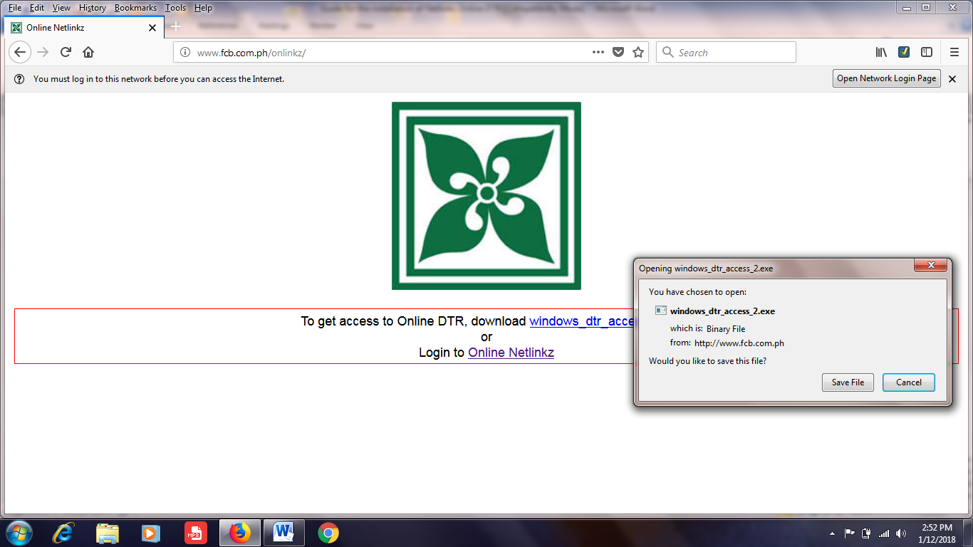
- If there’s a warning that the file downloaded may be dangerous, click the arrow up button. Then, click Keep.
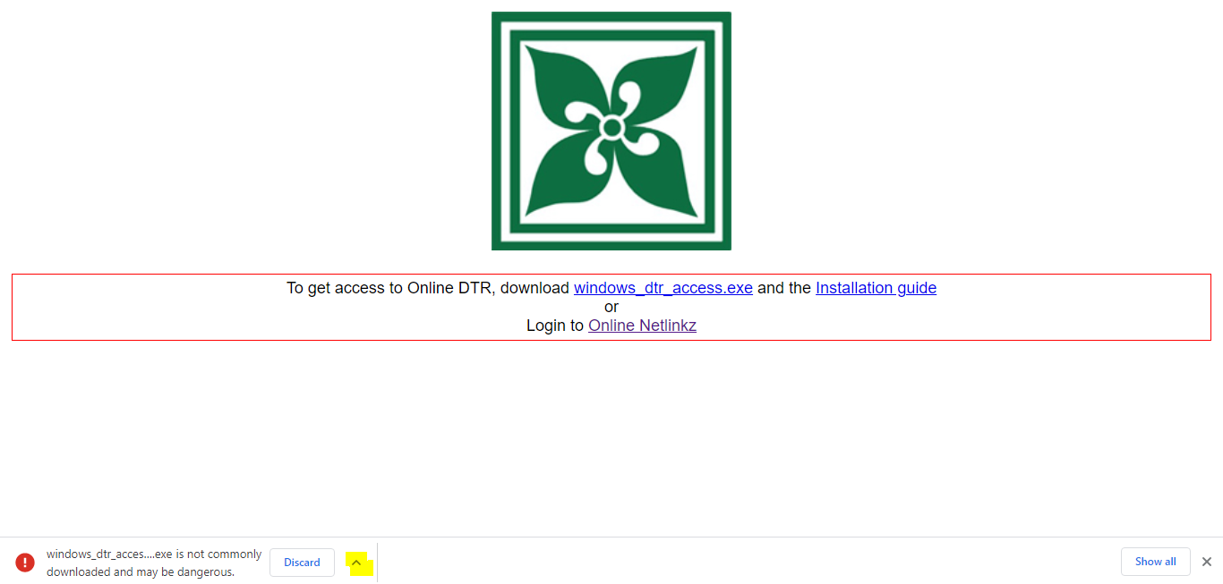
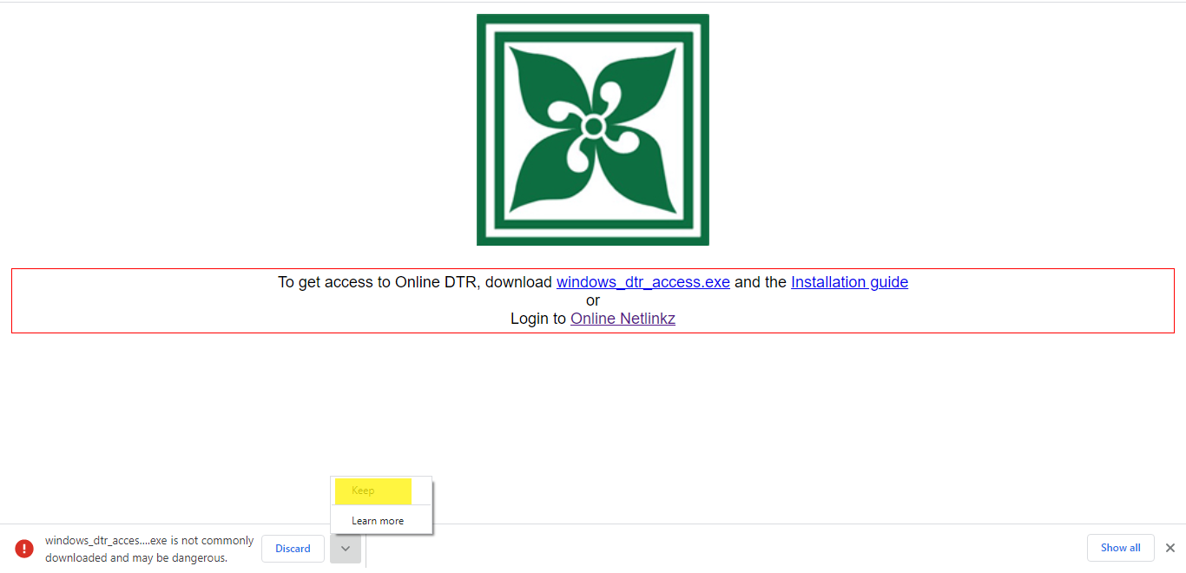

- Once done, click the file downloaded
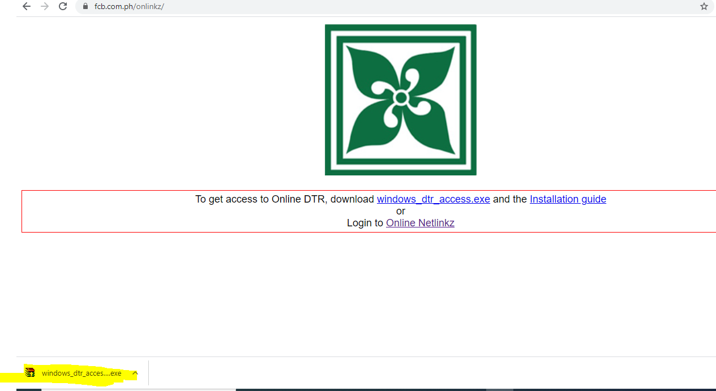

If the downloaded file is not displayed at the bottom, click the arrow down and click the file downloaded.
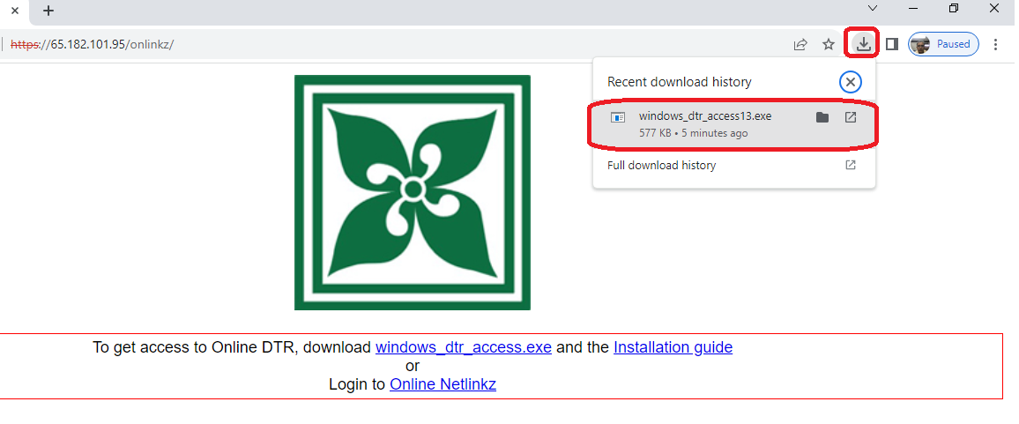

- For Mozilla Firefox users, after downloading the file, click the arrow down and click the file downloaded.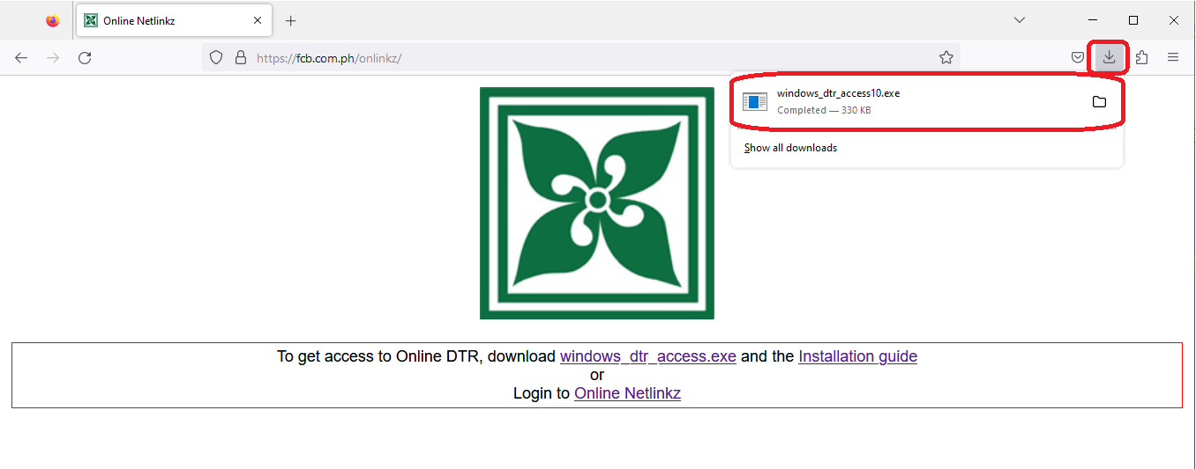

- Click Run.
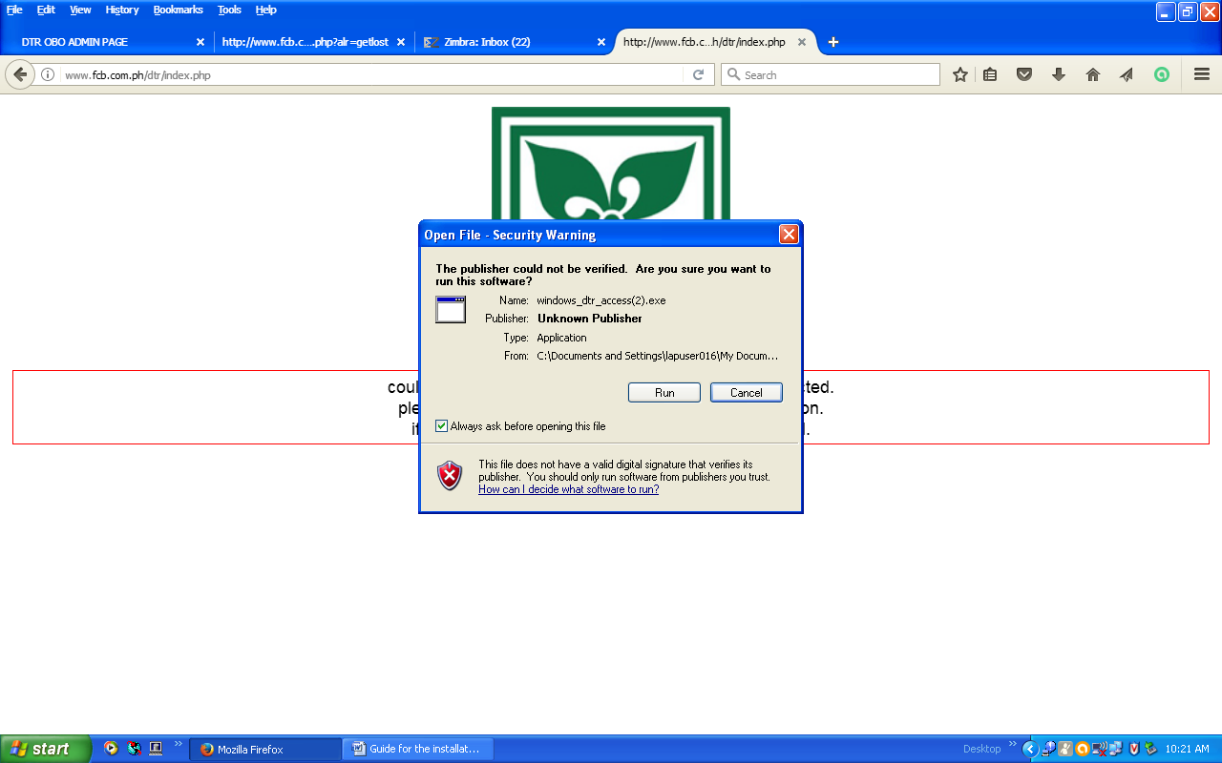

If Windows protected your PC pop-up appears, click More Info. Then, click Run anyway.
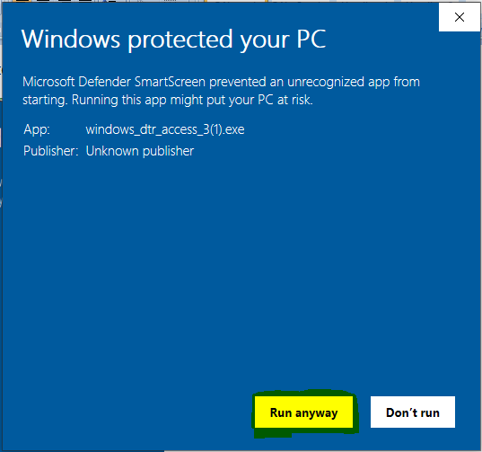
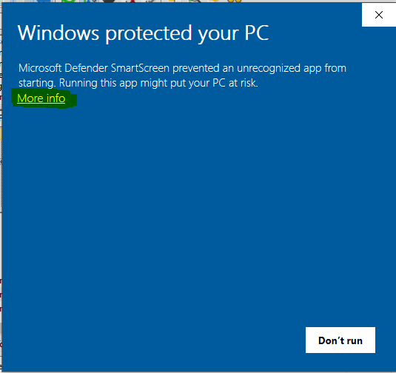

- If another window pops-up, click Extract.
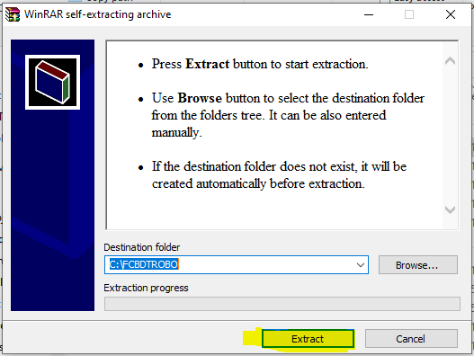

- After Clicking RUN/EXTRACT, go to Windows Explorer or My computer and go to C:\FCBDTROBO
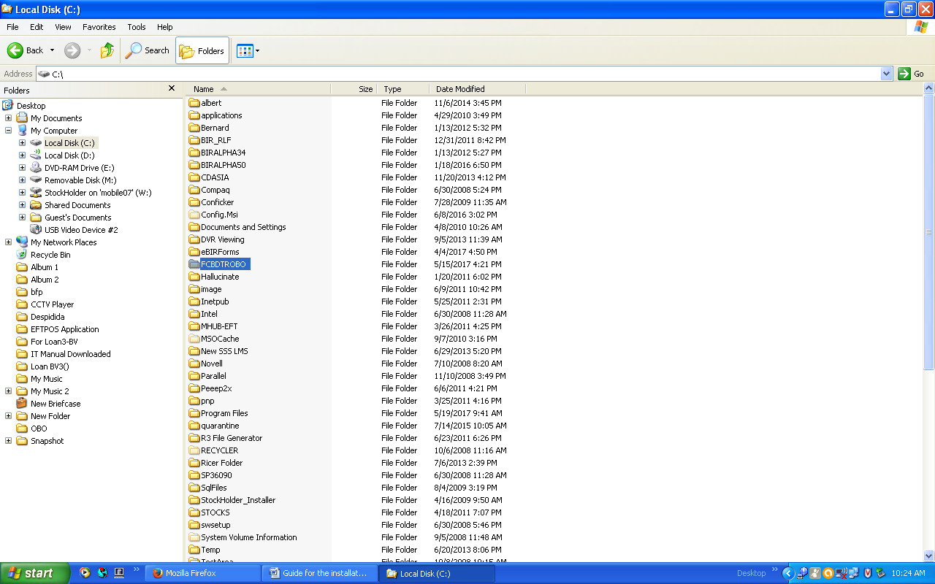

- To access Windows Explorer or My Computer.
  - Press windows button together with E button.
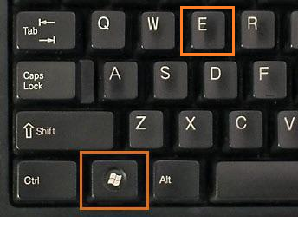
Or
Please click the folder icon in the taskbar.
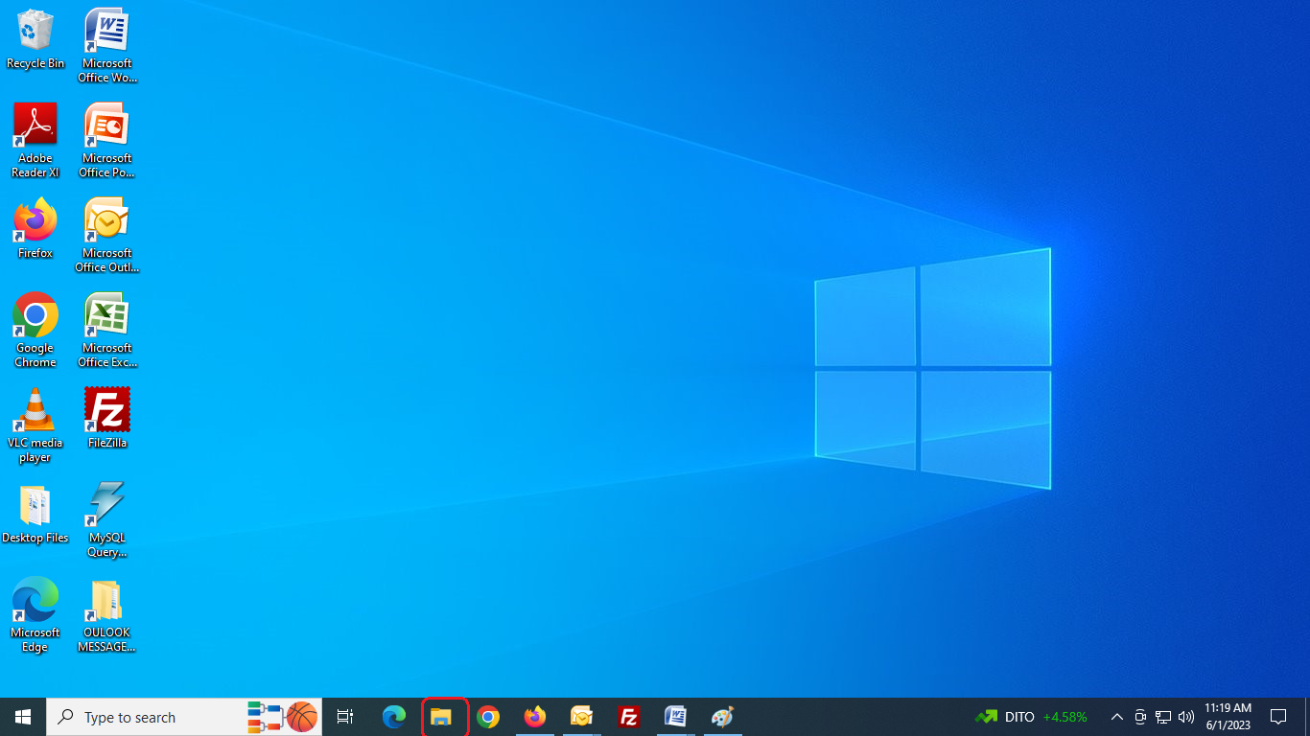

  - Once File Explorer appears, click Local Disk (C:)
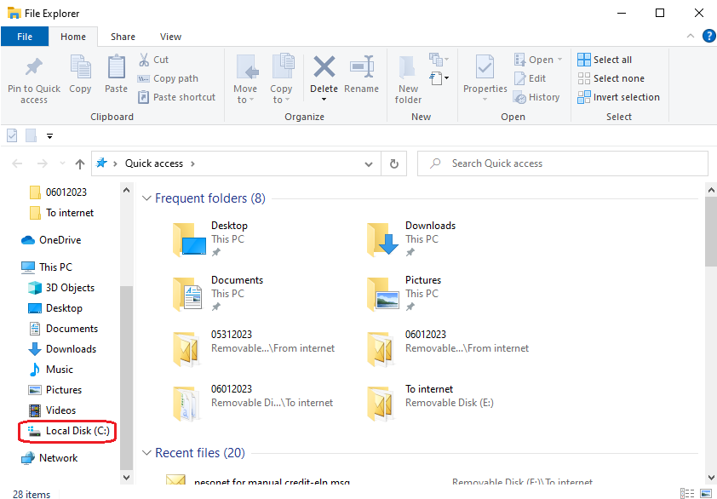

  - Then, double click FCBDTROBO.
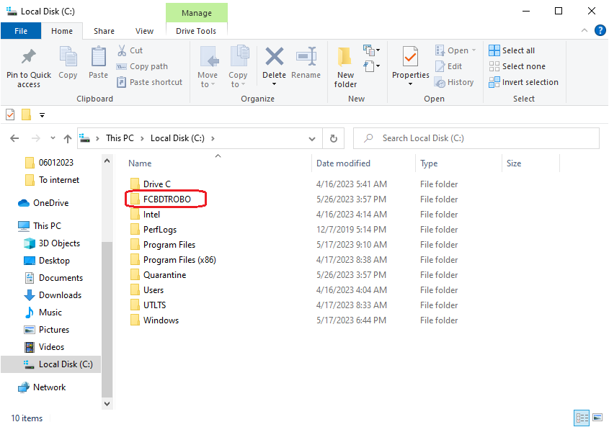
- Click windows_dtr_access.exe
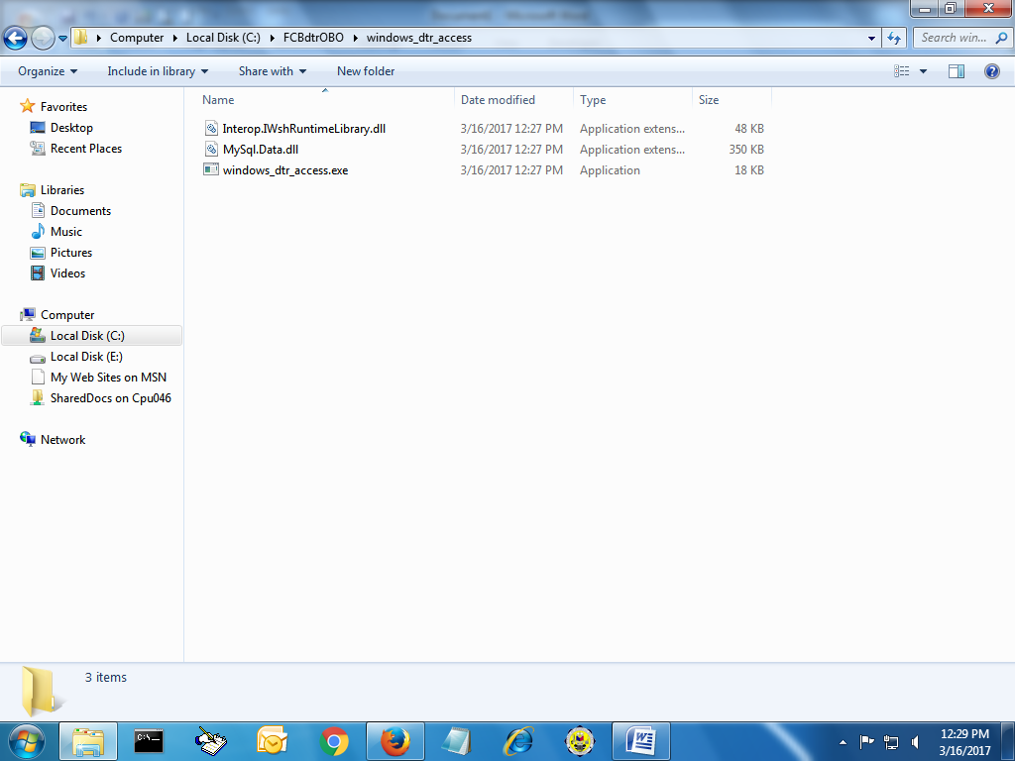

- A DTR OBO ACCESS will appear. Click Other Business Office field. For OBO installation, type the first three letter of your branch code and select the OBO code. Example: TAC-BOR. For Branch installation, type the first three letter of your branch code then select the code BRA (Branch). Example: TAC-BRA.
- If your Branch Code is not available in the list, please contact ICT Software immediately.
- Click “Register this Machine to HO”
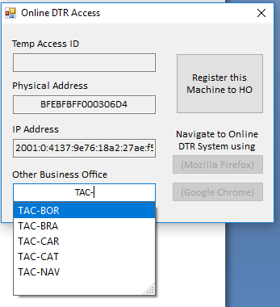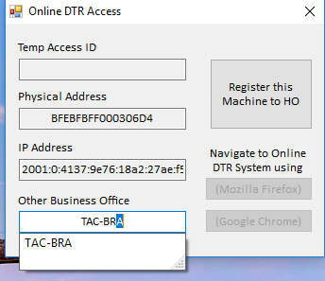

- A message will appear informing you that the registration is on process for approval.
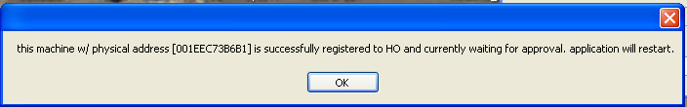
- An icon in the Desktop will appear.
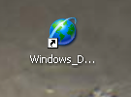

- Email us that you are already done with the machine registration.
- Wait for our email that your workstation has been approved for registration.

- Once you received our email/call that your workstation has been registered, click windows_dtr_access icon.
- A Security Warning will appear. Click Run.
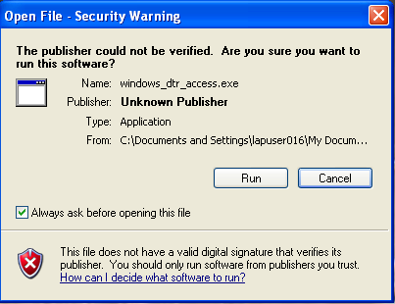

- DTR OBO ACCESS will appear. To navigate to Online DTR System, select Mozilla Firefox or Google Chrome.
- You can no longer change to Other Business Office. If it is incorrect. Please inform us immediately.
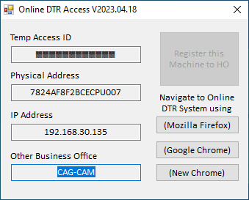
- If warning appeared after clicking Mozilla Firefox/Google Chrome/New Chrome button, click Advanced.
Firefox:
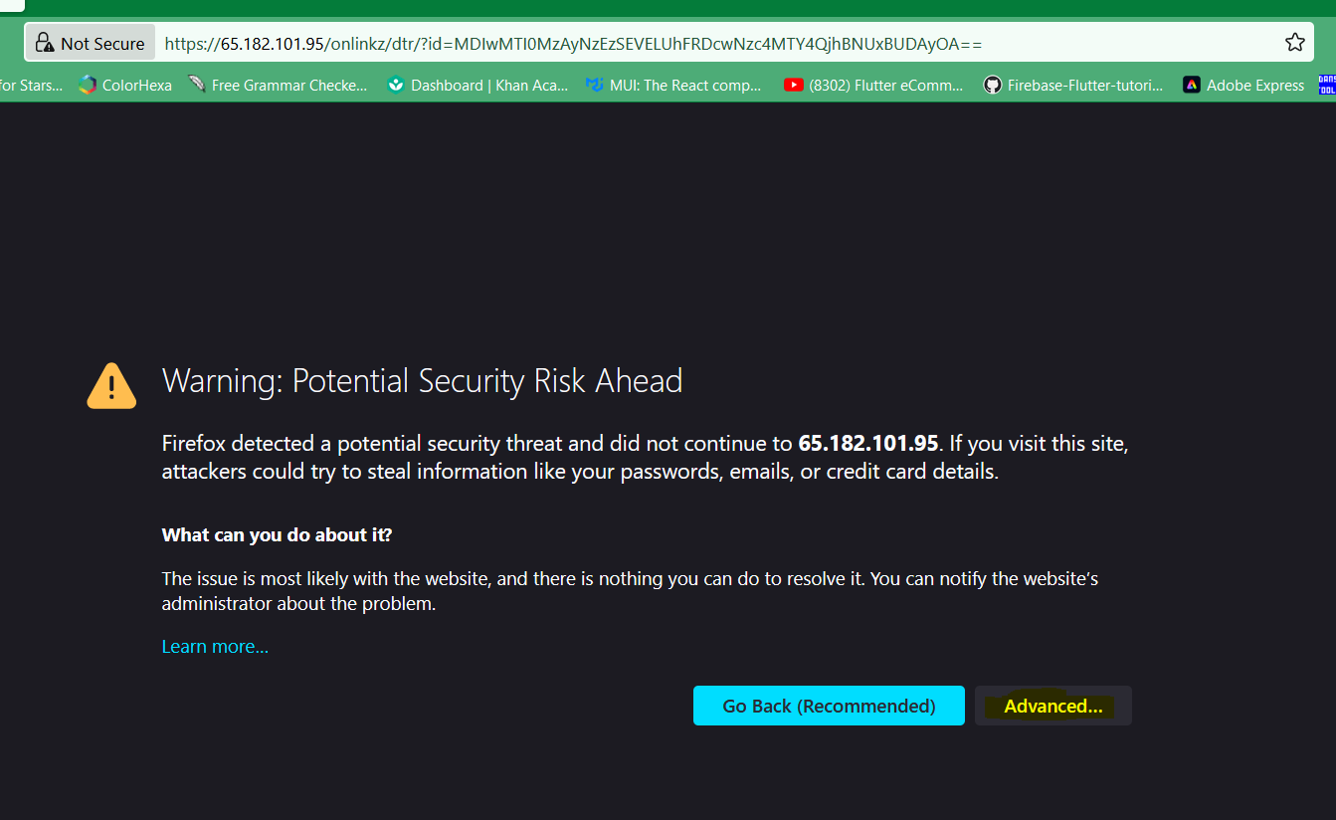

Chrome:
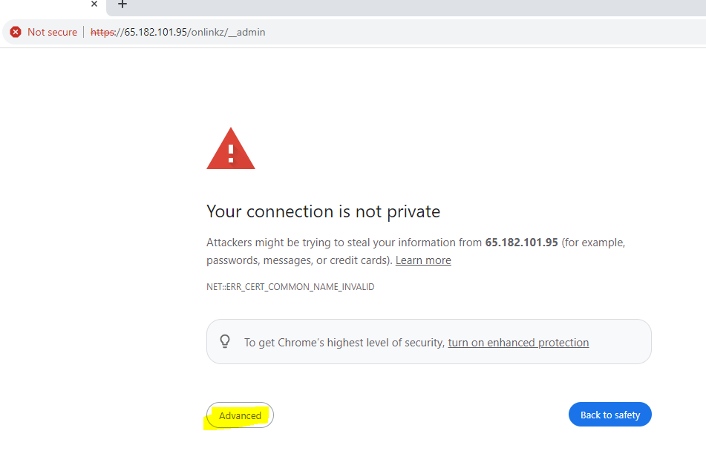

- Then click, Accept the Risk and Continue for Firefox browser.
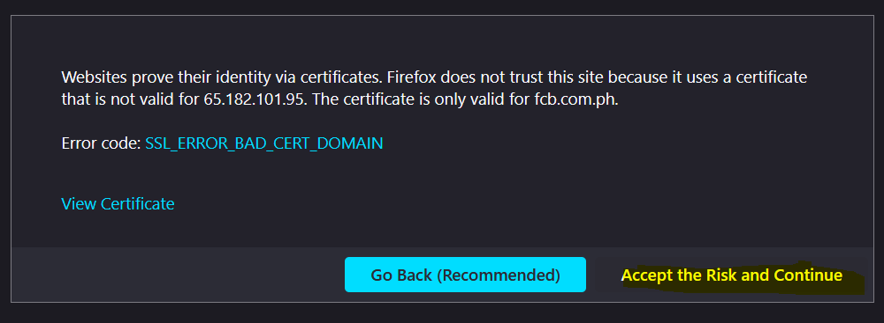

For Chrome browser, click Proceed to 65.182.101.95 (unsafe).
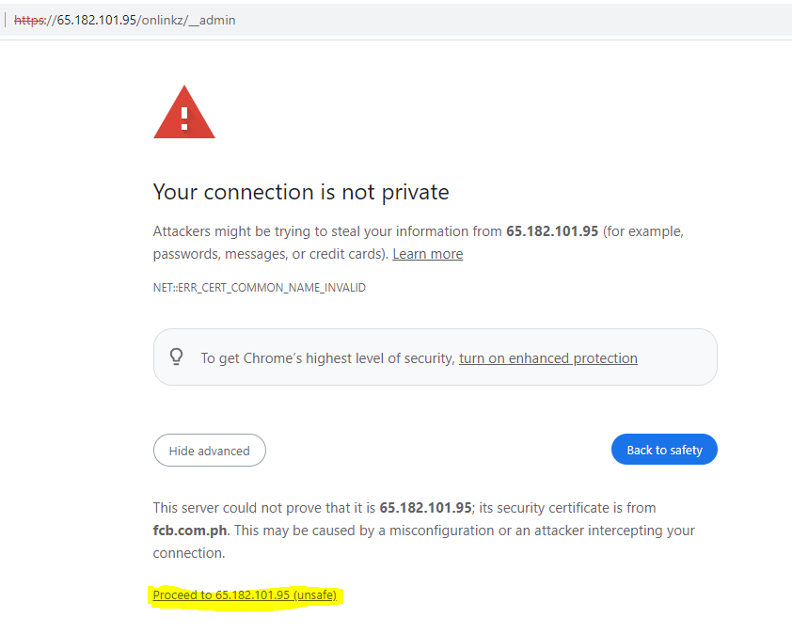

- Log-In using your Employees ID Number and the temporary password we gave to you. We suggest that you immediately change your password in the Profile Menu.
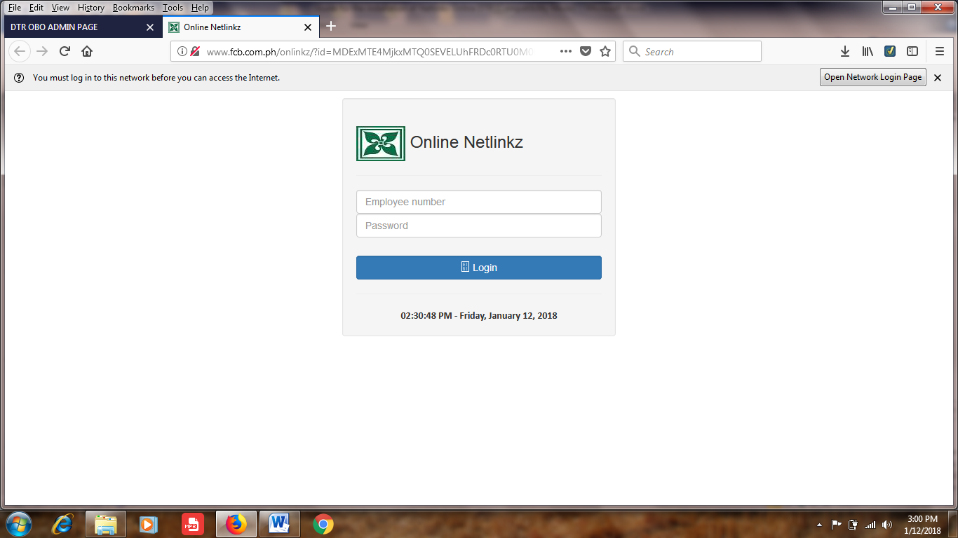

Note:
- We prefer that you print screen the errors and attached it in email.
- If you have concern, please call/email Gemma Fe Jala of the ICT Department.

